Java Script Basics 12/08/2025

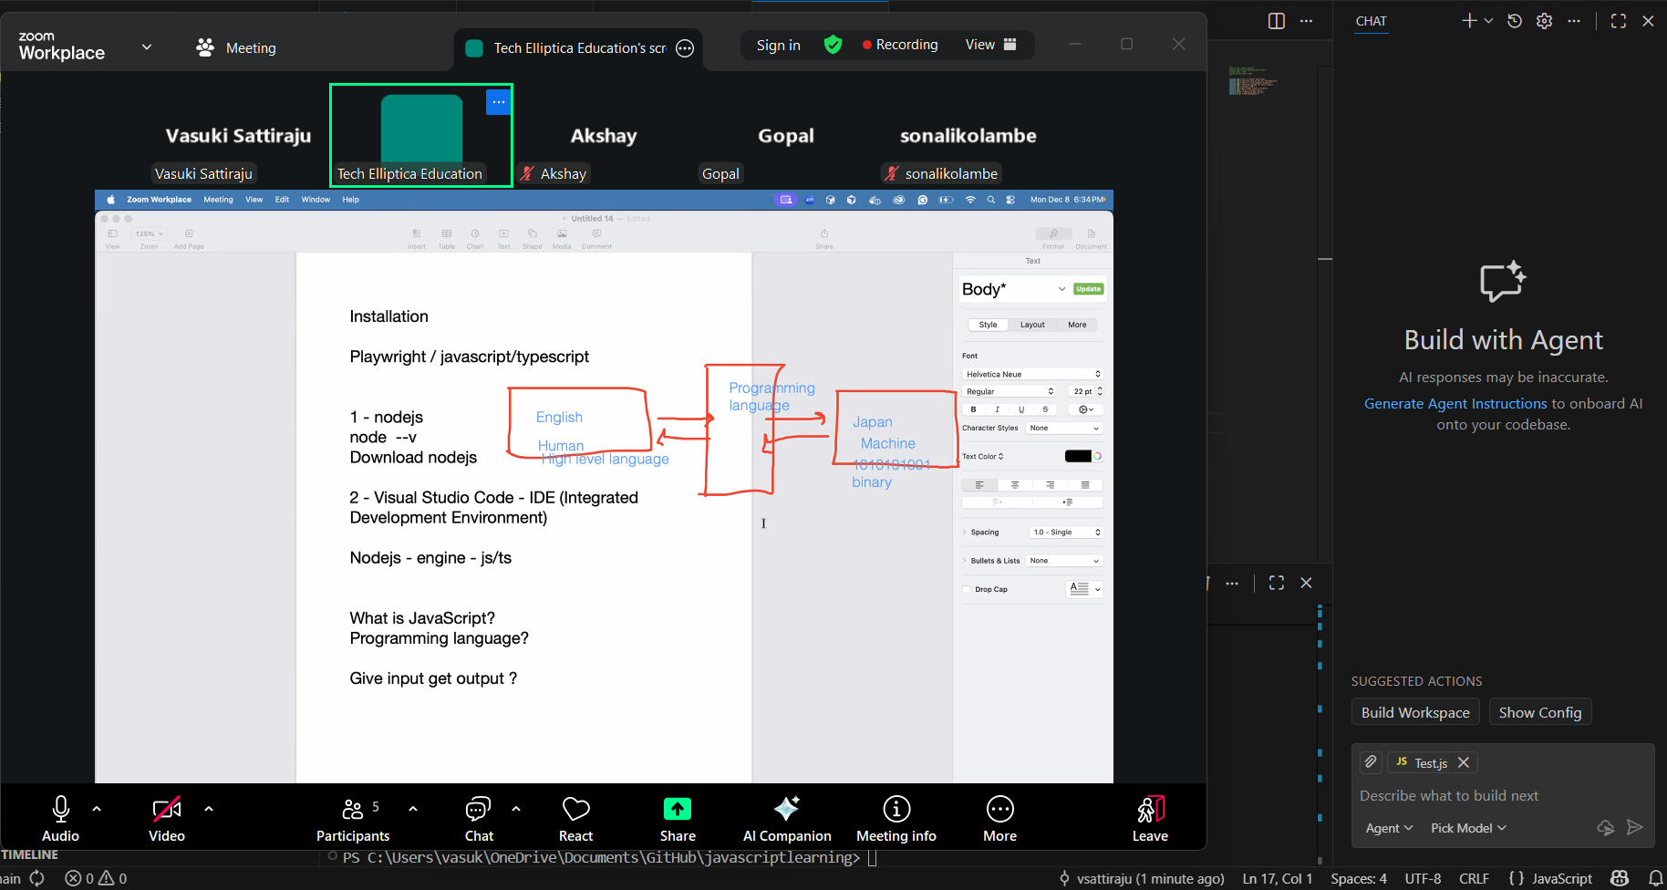

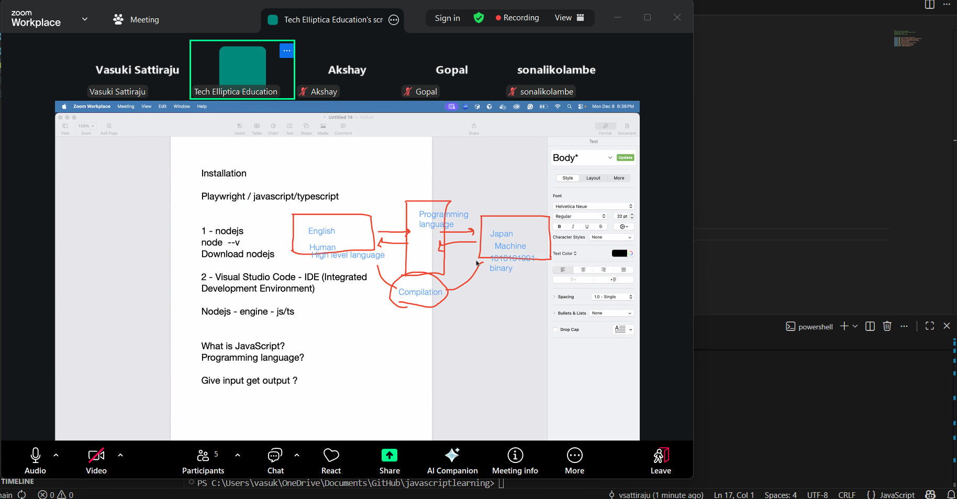

Java Script will not compile the code, just executes
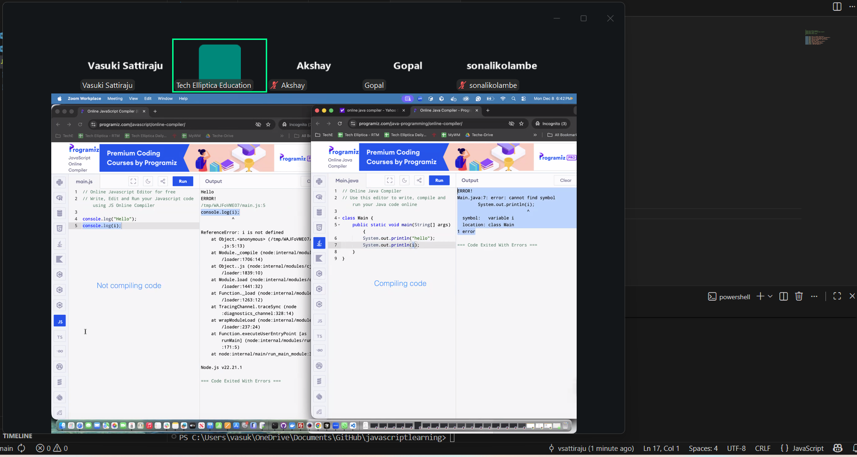
Visual Basic and Python will not able to compile the code because its JUST executes.
Using Arr object
